Name______________________________ Mr. Rives – Algebra 2X
Unit 6: Radical Functions and Rational Exponents

DAY | TOPIC | ASSIGNMENT
1 | 8.6 LAWS OF EXPONENTS  RATIONAL EXPONENTS  SIMPLIFYING EXPRESSIONS | Page 614 # 5-27 and 31-55 odd
2 | MORE 8.6 | WORKSHEET Day 2
3 | 8.7 RADICAL FUNCTIONS (mini-quiz)  GRAPHS AND APPLICATION | Page 624 # 8-10,24-26, 30-32, 39, 51-55a
4 | 8.8 SOLVING RADICAL EQUATIONS -INCLUDING 2 RADICALS | Page 632 # 2-22
5 | MORE 8.8 / review | Page 633 # 27-41, page 635 #71-73
6 | Quiz on days 1-5
7 | 9.4 OPERATIONS AND COMPOSITIONS OF FUNCTIONS | PAGE 686 # 15-17, 24-32, 39,40, 45-47
8 | 7.2 INVERSES OF RELATIONS AND FUNCTIONS | PAGE 501 # 1-16, 30, 34, 41-46
9 | 9.5 FUNCTIONS AND THEIR INVERSES | PAGE 693 # 9-19 ALL, 24-35 ODD, 47-50 ALL
10 | REVIEW | REVIEW SHEET
11 | Quiz On days 7-9

Vocabulary: a) Radical Expression:
Day 1: Laws of Exponents, Rational Exponents & Simplifying

- Rational Exponent:

A radical expression can be written as a rational exponent, and vice versa. Here’s how…

Properties of Exponents (Rational or Not)
Property in Words | Algebra | “Normal” Exponents | Rational Exponents
Product of Powers

Quotient of Powers

Power of a Power

Power of a Product

Power of a Quotient

EXAMPLES:
Sometimes it is easier to convert radical expression into rational exponents before simplifying.

1) 2) 3)

Other times we will need to simplify radical expressions.

Signs of Exponents and Radicals
To break down radicals, you must look at the ______________________.

Give the index: a) ______ b) ______

Whatever the index is, that’s how large of a “group” that you need to bring an item out of the radicand.

Examples: (you should have done this before in algebra 1 and especially in finite math)

a) index: ______ b) index: ______

For this unit, we will be interested in simplifying rational exponents – in many cases we use the rules from the previous page, but in some cases we will use the process for simplifying radicals.

(classtime: game or activity)
Day 2: HOMEWORK WORKSHEET

Day 3: Radical Functions – Graphs & Applications
Warm up: Continue the list of perfect squares as high as you can go…

 | 1 | 2 | 3 | 4 | 5 | 6 | 7 | 8 | 9 | 10 | 11 | 12 | 13 | 14
 | 1 | 4

Today we are going to look at graphing square roots like (knowing perfect squares will help).

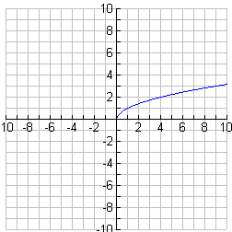
The parent function is __________________.

The general equation is . (slider demonstration)

a:

h:

k:

There are 3 ways to graph a square root: ___________________, ___________________, & table of values.

Method 1: Translations (best when the a value = ___)

a) b) c)

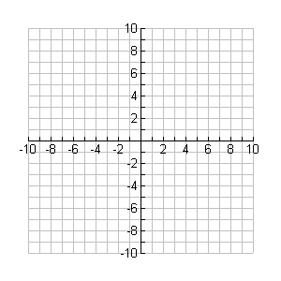
Starting point: __________ Starting point: __________ Starting point: __________
Method 2: Graphing Calculator (useful when , or anytime you are stuck on a graphing problem!)

Notes:

a) b) c)

Method 3: Table of Values (useful anytime, and can be combined with either of the other 2)

a) b) c)
x
y
x
y
x
y
Working backwards: Writing the equation when given a translation.

a) The parent function is translated 2 units to the left and one unit down.

b) The parent function is translated 3 units to the right.

c) The parent function is compressed vertically by a factor of and then translated 2 units up.

Individual Practice: Choose your method, but try some of each.

1) 2) 3)

4) 5) 6)

Closure: Describe the effect a, h, and k have on the equation

Day 4: Solving Radical Equations – Including 2 Radicals

Steps to Solve:

1. Isolate the radical if it is not already: Move terms first, and then divide by any coefficient of the radical.

2. Square both sides of the equation.

3. Solve the remaining equation using approaches you already know.

4. CHECK ALL POSSIBLE SOLUTIONS IN THE ORIGINAL EQUATION TO BE CERTAIN THEY

ACTUALLY GIVE YOU A TRUE STATEMENT! FALSE ANSWERS ARE ______________________!

1. 2.

3. 4.

5. 6. hmmmmmmm!?! What to do?

What if you have no radical, but you do have a rational exponent? How do you undo it?
Remember that a square root is the same as raising to the ½ power! Wouldn’t we square (raise to the 2nd power) to undo the square root if we have to get to the variable? So, …

RAISE BOTH SIDES TO THE ___________________ OF THE POWER YOU ARE TRYING TO UNDO!

7. 8.

9. 10.

_________________________________________________________________________________

11. Ok, now. What should we do with this one?
Day 5: Activity Practicing Yesterday’s Lesson

Day 6: Quiz on Day’s 1-5

Day 7: Operations and Compositions of Functions

Function Operations
Operation | Function Operation | Example in Terms of x | Example with numbers
Addition
Subtraction
Multiplication
Division | Domain Restriction!
Composition |  | Examples on next page! | Examples on next page!
Method 1: Finding the composition of a number.

Find .

Work Inside – Out → So first find___________ = _____ → Next, find

Try on your own:

Method 2: Find the composition of a variable.

Find .

Work Outside – In → Write out first →

Now, plug all of g: ( ) in for x →

Simplify →

What if we were trying to find ?

Note: If you were trying to find the composition of a number, you could use this method first and then plug in the number into your answer.
Additional Practice:

A ______________________ is a pairing of two values, normally in the form .
Day 8: Inverses of Relations & Functions

Plot each ordered pair given below. Then, write the inverse point by switching to .
Point | Inverse

Important: What line is each point reflected over?

Inverses are created by switching x with y. Let’s find the inverse of some equations…

a) b) c)

d) e)
Always change
to _____ first!

Directions: Find the inverse, then graph both the function and inverse

Question #1: What determines if a relation is a function or not?!

Questions #2: What are the domain and range of a relation (or function)?

Directions: Graph the relation and connect the points. Then graph the inverse. Identify the domain and range of each, and identify if either (or both) are functions or just relations.
x
y
-1
1
2
3
3
5
5
5
RELATION
x
y
INVERSE

Domain: Domain:

Range: Range:

Function?: Function?:

Graph the line that passes through the points and .

Next, graph the line through the inverse points.

Finally, find the slope of each of the two lines.
What’s the connection?

Additional Practice/Wrap Up: Find each inverse.

1) 2) 3)
Warm up: Are the following functions inverses? Explain how you know.
Day 9: Functions and their Inverses

There is another way to prove that two functions are inverses: By using ____________________ functions.

Let’s find and

When BOTH of these functions = ______, that means that the functions are inverses of each other!

Example #2: Determine if the following functions are inverses by using composition functions.

and

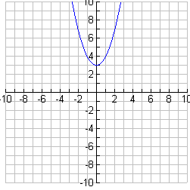
The graph of is shown.

First, graph the inverse by using the line of symmetry.

Next, find the inverse algebraically, and graph it
to check your graph of the inverse.

Is the inverse a function, or just a relation?

There is a trick to find if the INVERSE of a function will be a function without even finding the inverse.

This is known as the _______________________ line test (like the vertical line test, but horizontal!)
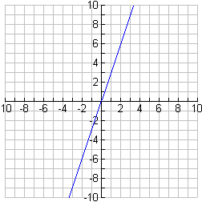
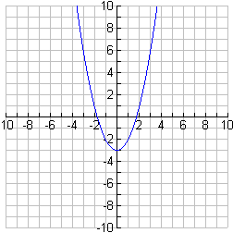
a) b)

Additional Practice:

Day 10: Review for Unit 6 Quiz
Given , , and , find the following:

1. 7.

2. 8.
(multiply)

3. 9.

4. 10.
compositions

5. 11.

6. 12.
(double composition)

13. Determine using composition if and are inverses. Explain how you know.

14. Refer to the graph.

Is the given graph a function? How do you know?  Is the inverse of the given graph a function? How do you know?  Draw the graph of the inverse on the same axes. | 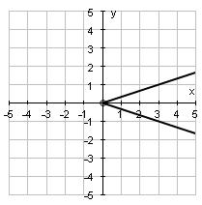

15. The points (9, 13) and (-4, 10) are on . Name 2 points on .

16. Is it always true that ? If yes, state why. If no, give an example where it’s not true.

1.) 10  2.) -9  3.) 5  4.) 10  5.) 29  6.) 16  7.)  8.)  9.)  10.) (composing a function and its inverse always yields x!)  11.) | 12.)  13.) They are not, since .  14.) The graph is not (fails VLT), but its inverse is (the graph passes HLT).  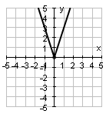  15.) (13, 9) and (10, -4)  16.) NO – you can use f and g from the 1st set of problems as your example!

