Name Date Period
Chapter 8: Photosynthesis

8.1 Energy and Life
Chemical Energy and ATP
For Questions 1–6, complete each statement by writing the correct word or words.
- Energy is the ability to do work.
- The main chemical compound cells use for energy is adenosine triphosphate (ATP).
- Ribose is a 5-carbon sugar molecule that is part of an ATP molecule.
- The phosphate groups of ATP are the key to its ability to store and supply energy.
- ATP releases energy when it breaks bonds between its phosphate groups.
- Most cells only store enough ATP for a few seconds of activity.

- Label each part of the diagram of an ATP molecule below.
adenine
3 phosphate groups
ribose
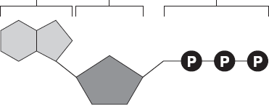

For Questions 8–10, refer to the Visual Analogy comparing ATP to a charged battery.

- In the visual analogy, what chemical is represented by the low battery?
ADP represents a low battery, which has been discharged
- What are two ways in which the diagram shows an increase in energy?
a brighter flashlight beam and a sunburst background
- Describe the concepts shown in the diagram.
When a phosphate group breaks off an ATP molecule, the remaining ADP molecule stores very little energy, like a discharged battery. When a phosphate group is added to ADP, the resulting ATP molecule stores a great deal more energy, like a recharged battery.

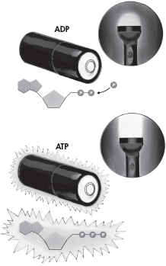

- What are two ways in which cells use the energy temporarily stored in ATP?
Active transport, cell movements, powering bioluminescence, making proteins, and other macromolecules

- Energy is needed to add a third phosphate group to ADP to make ATP. What is a cell’s source of this energy?
Food molecules such as sugars and starches

Heterotrophs and Autotrophs
For Questions 13–17, write True if the statement is true. If the statement is false, change the underlined word or words to make the statement true.
True 13. All heterotrophs must eat food to get energy.
True 14. Autotrophs do not need to eat food because they make food.
the sun 15. The energy in food originally came from ATP.
putting together 16. The term photosynthesis means “pulling apart with light” in Greek.
True 17. The energy of sunlight is stored in the chemical bonds of carbohydrates.

18. Complete the table comparing two types of organisms.
Autotrophs and Heterotrophs
Type | Description | Examples
Autotrophs | Organisms that can make their own food | Grass, algae, some bacteria
Heterotrophs | Organisms that obtain energy from the food they eat | Cheetahs, hares, mushrooms

19. Suppose that you ate a hamburger on a wheat roll with lettuce, tomatoes, and onions for lunch. As you ate, you took in food molecules from plants and animals. Explain why all the energy in the food molecules of this hamburger could be traced back to the sun.
The bread, lettuce, tomatoes, and onions in the hamburger all came from plants. The food molecules in those plants were made as a result of the process of photosynthesis, using the energy in the sunlight. The hamburger meat came from a cow, which ate grass and other plants to obtain food. The cow made the molecules in the meat by using the energy in the food molecules from the plants, which originally came from the sun.

8.2 Photosynthesis: An Overview
Chlorophyll and Chloroplasts
For Questions 1–6, complete each statement by writing the correct word or words.
1. The wavelength of light determines its color.
2. Chemicals that absorb light are called pigments.
3. Chlorophyll makes plants look green because it reflects green light.
4. Chloroplasts contain an abundance of saclike photosynthetic membranes called thylakoids.
5. The stroma is the fluid portion of the chloroplast located outside the thylakoids.
6. The visible light absorbed by chlorophyll raises the energy level of the chlorophyll’s electrons.

7. Label the internal parts of the chloroplast below.
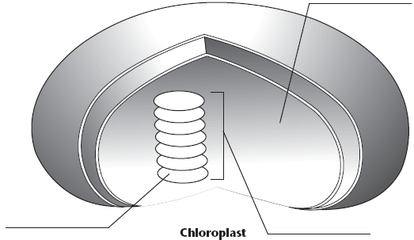
stroma
thylakoid
granum

High-Energy Electrons
For Questions 8–9, refer to the Visual Analogy comparing electron carriers to oven mitts.
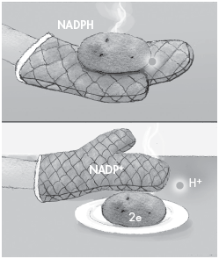
8. In the visual analogy of carrying electrons, what represents
the high- energy electrons?
The hot potato represents two
high-energy electrons

10. Where do the high-energy electrons
carried by NADPH come from?
The high energy electrons come from
chlorophyll molecules that have absorbed
sunlight.

An Overview of Photosynthesis
For Questions 11–13, write the letter of the correct answer on the line at the left.
B 11. What are the reactants of the photosynthesis reaction?
A. chlorophyll and light C. carbohydrates and oxygen
B. carbon dioxide and water D. high-energy electrons and air
C 12. What are the products of the light-dependent reactions?
A. chloroplasts and light C. oxygen and ATP
B. proteins and lipids D. water and sugars
A 13. Where do the light-independent reactions occur?
A. stroma C. chlorophyll
B. thylakoids D. mitochondria

14. Complete the illustration by writing the reactants and products of the light-dependent and light-independent reactions. Also, fill in the energy source that excites the electrons.

CO₂
LIGHT
H₂O
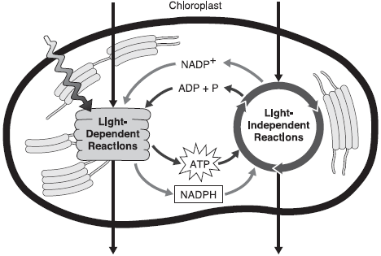
Sugars
O₂

15. Solar power uses cells or panels to absorb the sun’s energy. That energy is then used to create electricity. How does this compare to the light dependent reactions of photosynthesis?
Solar power and photosynthesis both use energy from the sunlight to create energy. The chloroplasts inside plant cells work like solar cells. The pigment chlorophyll in the chloroplasts absorbs the sun’s energy. The light energy is transferred to the electrons of the chlorophyll. It raises the energy levels of the electrons. The high-energy electrons are picked up by carriers and used to power chemical reactions in the cell.

