Unit 4 Quadratic Functions – Part A
- Some mini-quizzes will be unannounced but are always open note.
- HW Assignments will be worth 3 pts. Remember, if you don’t show work/setup you receive a zero.
- ALL GRAPHS ON GRAPH PAPER
Name____________________________ Period_____
DAY | TOPIC | ASSIGNMENT
1 | GRAPHING QUADRATICS FROM VERTEX FORM | 5.1 p. 320… # 1,2,4,5,6,14,15,22-25,39-41
2 | GRAPHING FROM STANDARD FORM AND IDENTIFYING VERTEX | 5.2 p. 328… # 1,3-6,14-16, 18, 20, 30, 33A (try to graph 30 and 33A on your calc)
3 | COMPLETING THE SQUARE-  CHANGING FROM STANDARD TO VERTEX FORM | 5.4 p. 345…# 1, 5-7, 14-19
 | Review day if needed  Mini Quiz | TBA
4 | FACTORING REVIEW  GCF, DIFFERENCE OF SQUARES, TRINOMIALS | WORKSHEET A - page 9
5 | FACTORING REVIEW  PERFECT SQUARE TRINOMIALS AND MORE TRINOMIALS | WORKSHEET B – page 12
6  MINI-QUIZ B | ZERO PRODUCT PROPERTY AND WRITING EQUATIONS WHEN GIVEN THE ROOTS (ZEROS) | 5.3p. 338… # 5-17 (use calc for #11)
7 | MORE SOLVING BY FACTORING | 5.3 p. 338… # 28-33, 35-59 (odd)
8 | ZEROS FROM GRAPHING CALCULATOR AND VERTICAL MOTION PROBLEMS | 5.3 p. 338…# 18-22, 30-36 (even), 41-43,  46 or 47 (Use your calc to graph)
9 | REVIEW FOR TEST A | TBA
10 | TEST A | Keystone Review
11 | SOLVING EQUATIONS BY COMPLETING THE SQUARE | 5.4 p. 345 #26-29, 41-45, 48 56, 57
12 | SIMPLIFYING RADICALS  COMPLEX ROOTS  EQUATING COMPLEX NUMBERS | 5.5 # p. 353…1, 18-21,26-28, 30,31,34, 37-39, 59-65 (odd)
13 | DISCRIMINANT TEST  QUADRATIC FORMULA | 5.6 p. 361… #1-7, 14-16 (find the discriminant for 14-16),  WORKSHEET D
14 | GRAPHING QUADRATIC INEQUALITIES-  SOLVING QUAD. INEQUALITIES | 5.7 p. 370… # 18-23, 35-45 (odd)
15  MINI-QUIZ C | ADD, SUBTRACT AND MULTIPLY COMPLEX NUMBERS | 5.9 p. 386 # 12-26
16 | POWERS OF I –DIVIDING COMPLEX NUMBERS | 5.9 p. 386…# 27-35, 61-64, 66, 68
17 | REVIEW | WORKSHEET E
18 | TEST B | Keystone Review

U4 D1: Graphing Quadratics from Vertex Form

- In unit 2, we looked at transformations → Let’s explore TI Interactive!

Quadratic Equation:
a
h
k
Vertex

- Examples together: Let’s translate each parabola to find the vertex, then use the “a” value to graph!

a) b) c)
Vertex: _______ Vertex: _______ Vertex: _______
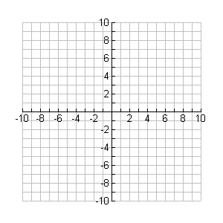

Working backwards: You know the transformation, you have to write the equation.

d) is stretched vertically by 3 and translated left 2

e) is reflected across the x-axis and translated 3 units up
The graph below illustrates the area of a room in a newly remodeled house. The “smaller” parabola was the original size, and the “larger” one represents the new size. Write the function of each parabola as a transformation of the function . Next, write the function for the larger size as a transformation of the function of the original size.
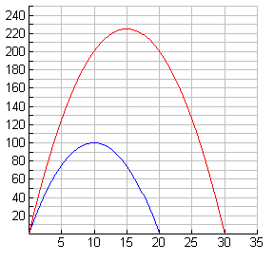
Function of Old Room:

Function of New Room:

Function of Old to New:

Classwork: Mail merge!
U4 D2: Graphing from Standard Form & Identifying the Vertex

- Yesterday we looked at quadratics in _________________ form. Ex:
  - This is convenient because we can easily identify the vertex: and the “stretch.”
- However, sometimes quadratics are written in ____________________ form:

- To review “FOIL,” let’s convert into standard form.

- From this form, we still want to be able to find the vertex (and other things)…

Standard Form:
 | Property | Example:
a positive
a negative
Max or Min?
Vertex
Axis of Symmetry
y-intercept

- How to graph …

Step 1: Plot the _________________

Step 2: Sketch the axis of symmetry.

Step 3: Plot the _________________

Step 4: Use symmetry to find __________

Step 5: Sketch!

1)  Direction: _________________  Axis of Symmetry: _____________  Vertex: _______________  Max or Min (and value): _________& __________  y-intercept: ___________ | 2)  Direction: _________________  Axis of Symmetry: _____________  Vertex: _______________  Max or Min (and value): _________& __________  y-intercept: ___________

WoRd: A record label uses the function to model the sales of a new release. The number of albums sold is a function of time, t, in days. On which day were the most albums sold? What is the maximum number of albums sold on that day?

WoRd AGaIn: A r
WoRd AGaIN
U4 D3: Completing the Square: Change from Standard to Vertex

- To start class yesterday, we converted the vertex form into standard form…

- What if we had to work backwards? .
This is known as ________________________ the square.

Fill the blanks with _______________

Vertex is: _________________

- One more together: This time there is a number front of ( ). Factor it out!!

Factor: Add & Subtract: ___________

Vertex: ________________

Check:
Classwork Problems:

Directions: Fill in the blank for each expression in order to complete the square.

1) 2) 3)

Directions: Write each function in vertex form, then identify its vertex.

- 5)

6) 7)

Closure:

Vertex form: Vertex is:

Standard form: Vertex is:

To complete the square, add and subtract ___________________ to .

Warmup: Following Mini Quiz A – factor the following! Remember, you can FOIL to check!
U4 D4: Factoring Review – GCF, Diff of Squares, Trinomials

1) | 2) | 3)
4) | 5) | 6)

- Factoring is the ____________________ process of expanding (multiplying through the distributive property, FOIL, etc).

- Review: Distribute and FOIL

a) b)

- Today we are going to tackle three types of factoring.
2 Terms |  | 3 Terms
GCF | Difference of 2 Squares | Guess and Check

HW Start!

U4 D4: HW – WORKSHEET A

Factor by removing a common factor:  1.  2.  3.  4.  5. | Check by distributing your answer:  1.  2.  3.  4.  5.
Factor using difference of squares, :  6.  7.  8.  9.  10. | Check by FOILing your answer:  6.  7.  8.  9.  10.
Factor:  11.  12.  13.  14.  15. | Check by FOILing your answer:  11.  12.  13.  14.  15.
Factor these various types:  16.  17. | 18.  19.  20.

U4 D5: Factoring Review – Perfect Square Trinomials & British

n | 1 | 2 | 3 | 4 | 5 | 6 | 7 | 8 | 9 | 10 | 11 | 12 | 13 | 14

What exponent does a variable have to have in order for it to be a perfect square? ________________!

Perfect Square Trinomials

→ →

Examples: 1) 2)

3) 4)

5) 6)

The British Method! Used when you have ________________________________.

a) b)

Directions: Factor each expression, if possible. If not possible, write “not factorable”

Factor these trinomial squares:  U4 D5: HW – WORKSHEET B  1.  2.  3.  4.  5.  6.  7.  8.  9.  10. | Check by FOILing your answer:  1.  2.  3.  4.  5.  6.  7.  8.  9.  10.
Factor:  11.  12.  13.  14.  15.  16.  17.  18.  19.  20. | Check by FOILing your answer:  11.  12.  13.  14.  15.  16.  17.  18.  19.  20.

U4 D6: Zero Product Property & Writing Eq. when Given Roots

- Reminder: The graph of a quadratic equation looks like a _______________. Today, we are interested in finding the place(s) where the graph crosses the ____________________. These values are known as the ______________________ or the ________________________ of the function (there is a slight difference, but we don’t need to worry about the technicality).

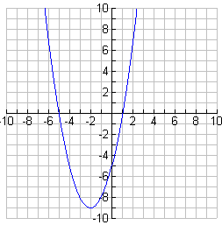
Today’s Goals:

1) Given the equation, find the roots/zeros/solutions

Zero _______________ Property: If , then…

2) Backwards → Given the roots, write the equation

Write as a product and _________________ it out!

- Examples together: Find the zeros of each function by factoring

a) b)

- Examples together: Write a quadratic function in standard form for each given set of zeros.

a) 6 and -3 b) -2 and 7

Classwork Activity (for the rest of today, and tomorrow)!
U4 D8: Zeros from Graphing Calculator and Vertical Motion

- Yesterday (and probably last year, too!) you learned how to find the zeros of a quadratic function. Today we are going to look at a real world application of this: _________________ motion
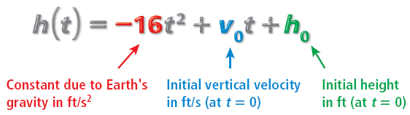

is 0 (disappears) when…
How hard you kick/throw/shoot the object from the beginning

Example #1: A soccer ball is kicked from the ground level with an initial velocity of 32 ft/s. After how many seconds will the ball hit the ground?

Step 1: Write the general projectile function →

Step 2: Plug in anything you can →

Step 3: When does it mean for the ball to hit the ground? Answer: ____________________________!

So, set …

Calculator Notes:

Example #2: Marilyn hit a golf ball on the ground with her driver. Use the general function for a projectile to write a function that shows the height in feet of her golf ball as a function of time. The ball was hit with an initial vertical velocity of 100 feet per second.

How long will Marilyn’s ball stay in the air?

Example #3: A rocket is launched from the ground with an initial velocity of 144 ft/sec. (All work is to be done without using a calculator to graph. You may check your answers by graphing.)

- Write a function that represents this situation.

- At what time(s) will the rocket be 320 feet in the air?

- What is the maximum height of the rocket? How long does it take for the rocket to reach this height?

- When will the rocket hit the ground?

Closure: What is the general projectile function? Explain each term. What is the function used for?!
U4 D9: Review for Unit 4 Test A

Directions: Solve by factoring:

1) 2)

3. Use completing the square to put this equation in vertex form. Then find the vertex.

Vertex form: ___________________________ Vertex:_________________

For the problems below, make sure your answers are in the right format (point, line, number, etc.)!
Find the information below then sketch the graph:

4.

which way does it open?_______________

Has a MAX or MIN?_______________

Vertex: _________________

Axis of Symmetry:_______________

Max / Min value:________________

Use the info to sketch the graph:

5.

which way does it open?_______________

Has a MAX or MIN?_______________

Vertex: _________________

Axis of Symmetry:_______________

Max / Min value:________________

Use the info to sketch the graph:

6. Here’s a graph…tell me the info:

Which way does it open?  Has a MAX or MIN?_________  Vertex: _________  Axis of Symmetry:________ | Max / Min value:  y-intercept:____________  x-intercepts:__________  Given that a = -1, write the equation in vertex form:  __________________________ | 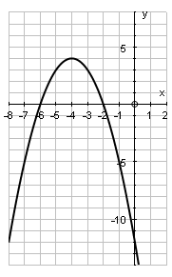

7. Factor each of the following.
a) b)

_________________________ _____________________________

c) d)

__________________________ _______________________________

e) f)

_____________________________ _____________________________

8. For each problem below, you are given the roots of an equation. Find the factors, then write the equation in standard form.

a) 3 and – 4 b) -17 and –5

________________________ ____________________________

9. Use your calculator to find the following information for the quadratic function .

Vertex is________________ zeros are _________________

  - The late great Mr. Rogers dropped a ball in the Land of Make Believe off the top of the castle that has a height of 50ft.

- Write a function that describes the position of the ball as a function of time.

- Determine when the ball hits the ground.

